**Google Account Security Enhancement: MFA Implementation Report**

**1. Steps Followed to Enable MFA**

I successfully implemented Multi-Factor Authentication on my Google account by following these steps:

1. Logged into my Google account through my web browser
2. Navigated to Google Account settings by visiting the Google Account page
3. Accessed Security Settings by clicking on "Security" in the left-hand menu
4. Located the "Signing in to Google" section within the security page
5. Selected the "2-Step Verification" option and followed the prompts
6. Entered my account password to proceed with the setup
7. Chose my preferred MFA method from the available options
8. Completed verification by entering the code sent to my chosen method
9. Saved the backup codes provided for emergency access
10. Tested the MFA setup by logging out and logging back in

**2. Chosen Authentication Method(s)**

For my MFA implementation, I selected the following authentication methods:

* **Primary Method**: Google Authenticator App
  + I installed the Google Authenticator app on my smartphone
  + Scanned the QR code displayed during setup
  + The app now generates time-based codes for authentication
* **Backup Method**: Text Message Verification
  + I registered my mobile phone number to receive backup codes
  + This serves as a fallback option if I can't access my authenticator app

**3. Screenshots of Key Setup Steps**

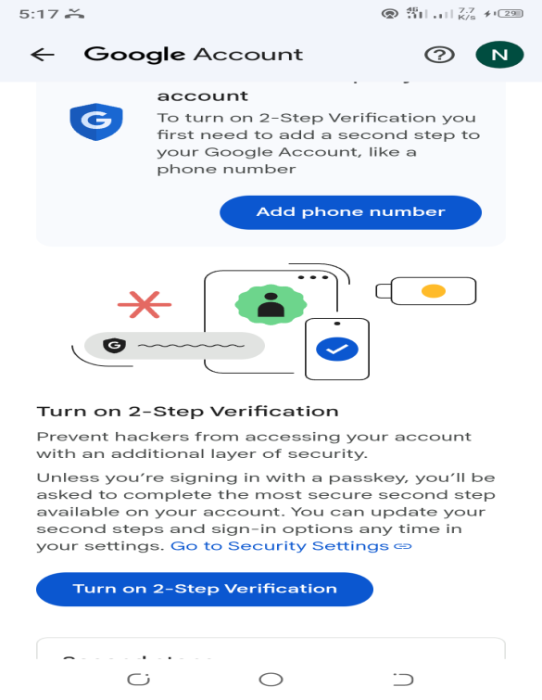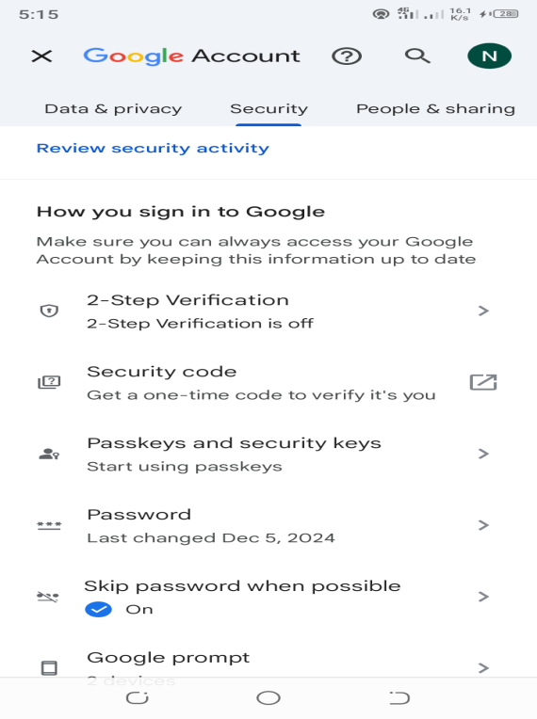

**4. Observations About the Process and Its Importance**

* **Ease of Implementation**: The setup process was straightforward and user-friendly. Google provides clear guidance throughout each step, making it accessible even for users with limited technical knowledge.
* **Time Investment**: The entire process took approximately 10-15 minutes, which is a minimal time commitment considering the significant security benefits.
* **User Experience Impact**: After enabling MFA, the login process requires an additional step but adds only a few seconds to the authentication process. This minor inconvenience is vastly outweighed by the enhanced security.
* **Security Improvement**: MFA significantly strengthens account security by requiring possession of a physical device in addition to password knowledge. This creates a substantial barrier against unauthorized access.
* **Peace of Mind**: Knowing that my sensitive information is protected by multiple layers of security provides reassurance, especially considering the amount of personal and financial data stored in my Google account.

**5. Recommendations for Maintaining Account Security**

1. **Regular Security Checkups**: Perform Google Security Checkups quarterly to review account activity and security settings.
2. **Update Recovery Options**: Keep recovery phone numbers and email addresses up to date to ensure access to account recovery options.
3. **Manage Connected Applications**: Regularly review and remove access for unused third-party applications that have permissions to your Google account.
4. **Store Backup Codes Securely**: Keep backup codes in a secure, offline location that is accessible in emergencies but protected from unauthorized access.
5. **Password Management**: Continue to use strong, unique passwords and consider using a password manager for additional security.
6. **Device Security**: Maintain security on all devices that access your Google account by keeping operating systems and applications updated.
7. **Phishing Awareness**: Remain vigilant about phishing attempts that may try to steal authentication credentials, even with MFA enabled.
8. **Consider Security Key**: For maximum security, consider investing in a physical security key (like YubiKey) as they provide the strongest protection against phishing attacks.